Exercise

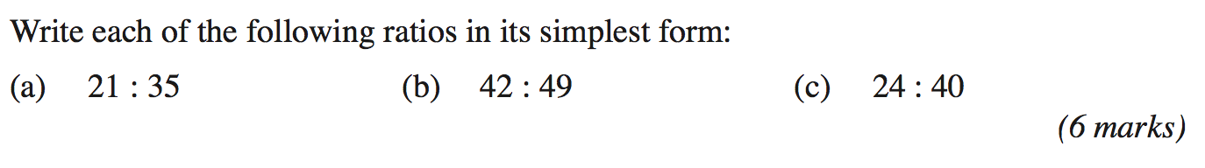

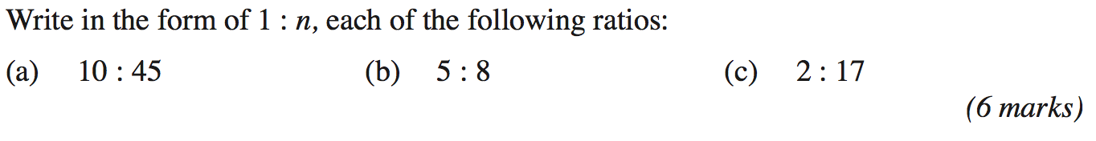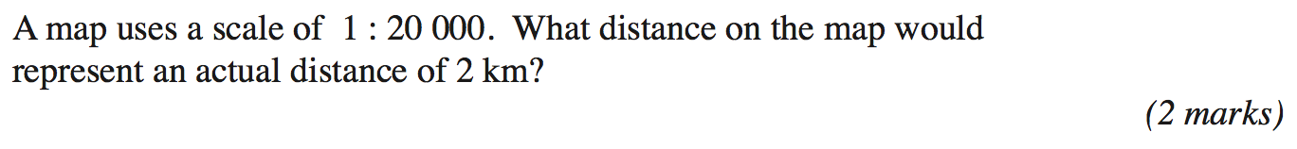

A bicycle shop increases all its prices by 12%. One of their bicycles now costs £134.40. What was its price before the increase?

…………………………….

**(Total 2 Marks)**

A crowd of 38,270 at a Premier Division football match was 14% fewer than the previous week. How many went to the previous week’s match?

…………………………….

**(Total 2 Marks)**

On a radar, two boats appear 4cm away from each other, when in fact they are 80km away from each other. What is the ‘map scale’ of the radar?

…………………………….

**(Total 2 Marks)**

Bytes is a shop that sells computers and digital cameras.

In 2003, Bytes sold 620 computers.

In 2004, Bytes sold 708 computers.

Work out the percentage increase in the number of computers sold.

.................................................

**(Total 2 marks)**

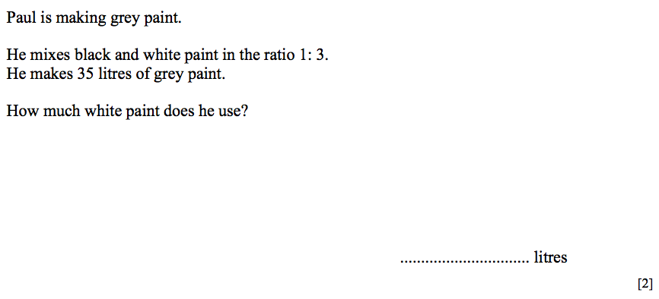

…………………………….

**(Total 2 Marks)**

If a boat cost £350,000 and its value increased to £420,000, by what percentage has the value increased?

…………………………….

**(Total 2 Marks)**

The ratio of cats to dogs in a pet shop is 5:7 and the ratio of dogs to mice also 5:7. What is the ratio of cats to mice?

…………………………….

**(Total 2 Marks)**

A map scale is 1 : 20 000. On the map, two points are 4.1cm away from each other. How far apart is that in real life? Give your answer in km.

…………………………….

**(Total 2 Marks)**

Here are the ingredients needed to make 12 shortcakes.

Shortcakes

Makes 12 shortcakes

50 g of sugar

200 g of butter

200 g of flour

10 ml of milk

Liz makes some shortcakes. She uses 25 ml of milk.

(a) How many shortcakes does Liz make?

…………………………….

**(Total 2 Marks)**

Robert has 500 g of sugar

1000 g of butter

1000 g of flour 500 ml of milk

(b) Work out the greatest number of shortcakes Robert can make.

…………………………….

**(Total 2 Marks)**

There are 800 students at Prestfield School. 45% of these 800 students are girls.

(a) Work out 45% of 800.

…………………………….

**(Total 2 marks)**

There are 176 students in Year 10.

(b) Write 176 out of 800 as a percentage.

…………………………….

**(Total 2 marks)**

225 grams of flour are needed to make 9 cakes.

Marian wants to make 20 of these cakes. She has 475 grams of flour.

Does Marian have enough flour to make 20 cakes?

You must show all your working.

…………………………….

**(Total 3 Marks)**

Last year Kerry’s take home pay was £15,000

She spent 40% of her take home pay on rent.

She used the rest of her take home pay for living expenses, clothes and entertainment in the ratio 3 : 1 : 2

How much did Kerry spend on entertainment last year?

.................................................

**(Total 4 marks)**

Fred has a recipe for 30 biscuits.

Here is a list of ingredients for 30 biscuits.

Self-raising flour: 230g

Butter: 150g

Caster sugar: 100g

Eggs: 2

Fred wants to make 45 biscuits. Complete his new list of ingredients for 45 biscuits.

Self-raising flour: …………………

Butter: …………………

Caster sugar: …………………

Eggs: …………………

**(Total 3 Marks)**

